

**OPERATING SYSTEM LAB**

**TAYYABA REHMAN 49690**

**LAB 5**

* **TASK 1:**

Run all switches with **uname** command.

-r, -m, -p, -I, -o, -a, -v, -n

And define in one line about these commands according to your understanding.

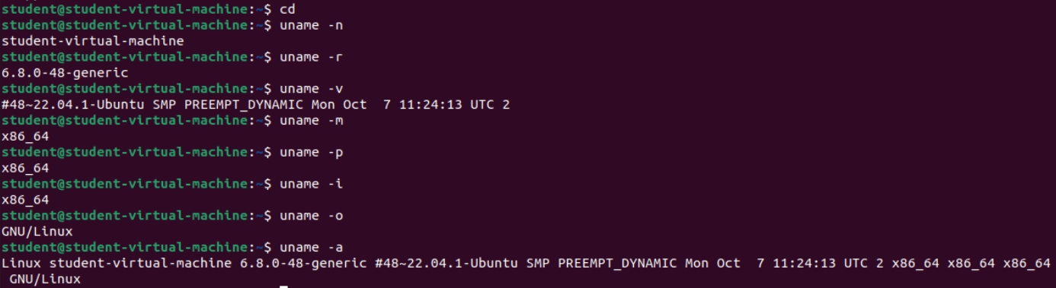

|  |  |
| --- | --- |
| **COMMANDS** | **FUNCTIONS** |
| uname -n | Tells name of the virtual machine |
| uname -r | Tells release version of Kernal |
| uname -v | Tells detail name of version |
| uname -m | It tells about the architecture. |
| uname -p | It tells about the processor type. |
| uname -i | It tells about the hardware plateform. |
| uname -o | It tells about the name of operating system. |
| uname -a | It tell about all the information together. This includes username, name of OS, name of machine, Kernal properties and it’s name and also the name of architecture. |

* **TASK 2:**

Create new file named **labSort** and insert following text

End of file

6 apples

file to be sorted

apple on the table

23 years old

File To be Sorted

78 apples

Class

3 bananas

99 sort files

Use other option with sort command and observe output.

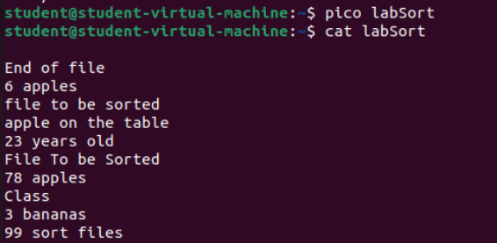

* **Sort**

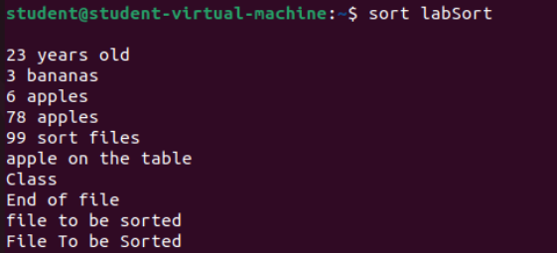

* **Sort -r**

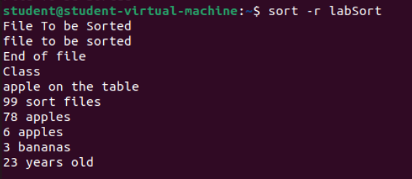

* **Sort –b**

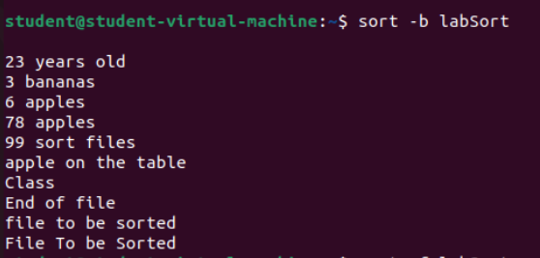

* **Sort –f**

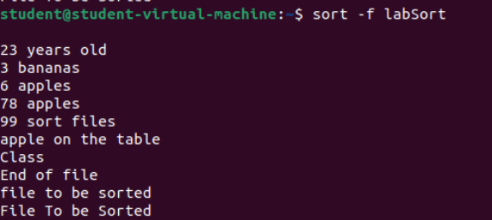

* **Sort –k**



* **Sort –n**

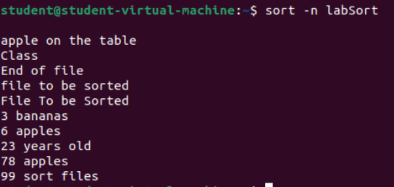

* **TASK 3:**

Create another file with name **SortLabNumeric** two columns in it.

12 Online classes

6 Network security

14 Hacking stories

7 Tom and jerry

13 People of Pakistan

One column contains numeric values while other contain text. Now perform sorting on both columns. Also perform **-n** switch on both columns again and observe the pattern.

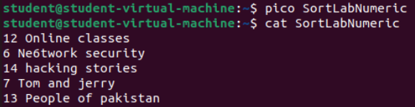

* **Sort –k 1 filename**

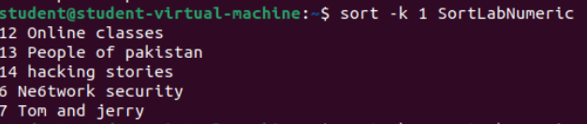

* **Sort –k 2 filename**

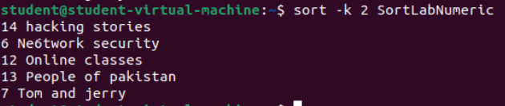

* **Sort –n**

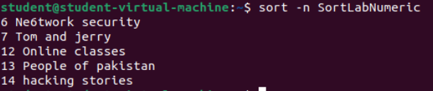

* **TASK 4:**

**Explain the Linux ‘cd’ command options along with the description?**

There are 4 cd Linux options. Their description is given below:

|  |  |
| --- | --- |
| **COMMANDS** | **DESCRIPTION** |
| cd | It is used to change the directory. E.g., If we write cd Downloads, then it will go to Downloads. |
| cd / | It uses to go in the root (topmost) directory. |
| cd.. | It is used to go back to the parent directory from the subdirectory. We will go one directory back. |
| cd dir_name | To change to any sub-directory under the current directory. E.g., If we have home/student and we write cd home then it will go to home not in student. |